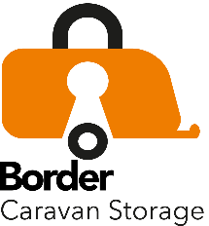

Border Caravan Storage Enquiry Form
Please complete and return to enquiries@bordercaravanstorage.co.uk
Title
First Name
Last name
Address
House name
House number
Road/Street
Village or town
Post Town
County
Postcode
Tel no
Mobile no
email
Unit Type | Caravan single axle |  | Caravan twin axle |  | Motorhome
Overall shipping length
Width of unit
Make of unit
Model of unit
Year of manufacture
Date storage required

